A1140-Afr-Egy-Amulet-Ba-Saite Period-26th Dynasty, 664-525 BCE-Blue Faience

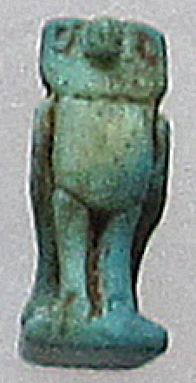 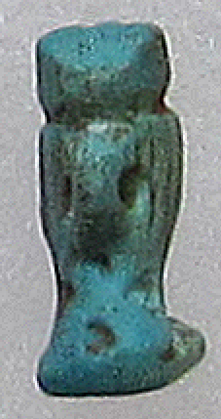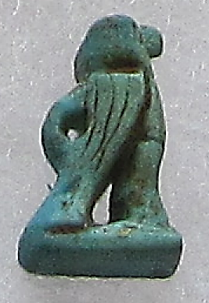

**Case No.: 2**

**Formal Label:** Amulet-Ba-Saite Period-26th Dynasty, 664-525 BCE-Blue Faience

**Display Description: This** amulet of Ba from the Saite Period of the 26th Dynasty, 664-525 BCE, is made of blue-green faience and depicts Ba as an owl. The [Egyptians](https://en.wikipedia.org/wiki/Ancient_Egypt) believed that a human soul was made up of five spiritual parts: the *Ren*, the *Ba*, the *Ka*, the *Sheut*, and the *Jb*, and the total body, the *ha*.Ba was the person or entity itself and one of its modes of existence (Zabkar 1968). Suspension loop on reverse.

**Accession Number: A1140**

**LC Classification:** DT62

**Date or Time Horizon:** Saite Period, 26th Dynasty, 664–525 BCE

**Geographical Area: Sais, Egypt**

**Map, GPS Coordinates:** 30.96650 30.76751, 30º57'59.41" N 30º46'3.02" E

 

Fig. Left. Sais on the Nile after http://latitude.to/lat/30.96606/lng/30.76785. Fig. Sais reconstructed according to Jean-Claude Golvin, http://jeanclaudegolvin.com/sais-2/.

**Cultural Affiliation:** Saite Period, 26th Dynasty, 664–525 BCE.

**Medium:** Blue Faience

**Dimensions: H 18.850 mm, 0.728 in; W 11,87 mm, 0.47 in.  
Weight: 1 gm, 1/8 oz**

**Provenance: Old European Collection**

**Condition:** Original

**Discussion:** The deceased lives a full life through his living *Ba*, which stresses a continuous activity of the Ba through the use of the imperfective active participle “living” (Zabkar 1968: 142). The *Ba* is the living individual, quite apart from the corpse, which however, can be revivified by the “opening of the mouth” ceremony that enables it to partake of bodily action, but it is the Ba that is the unique personality of the individual (Allen 2001: 161-162).

**References:**

Allen, James Paul. 2001. "Ba". In *The Oxford Encyclopedia of Ancient Egypt*, edited by Donald Bruce Redford. Vol. 1 of 3 vols. Oxford, New York, and Cairo: Oxford University Press and The American University in Cairo Press.

Žabkar, Louis Vico. 1968. *A Study of the Ba Concept in Ancient Egyptian Texts*. Studies in Ancient Oriental Civilization 34. Chicago: University of Chicago Press